_______________
New Carlisle
Cemetery Board
Appointed by the
Town Council
- Joyce Gard, President
Term Expires 12-31-2029
- Nancy Pemberton, Council Liaison
- Carol Middlebrook
Term Expires 12-31-2028
- Dave Doll
Term Expires 12-31-2027
- Sue Moffitt
Term Expires 12-31-2026

________________

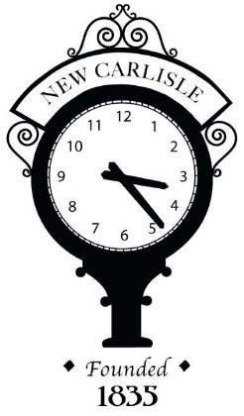

________________
New Carlisle Cemetery Board Meeting
124 E. MICHIGAN ST. NEW CARLISLE, IN 46652

Tuesday, February 17, 2026
1:00 PM

Join the meeting now (with a laptop use CTRL + Click to follow the link) or use the following information:
MS Teams Meeting ID: 259 119 604 177 7, Passcode: YM99EL7M

REMINDER: THIS MEETING IS LIVE AND IS BEING RECORDED

AGENDA

- Call to Order
- Approval of Minutes
- Old Business
- New Business
Spring Clean-Up
- Public Comment*
- Adjourn

**Visitors who wish to speak are asked to please sign in prior to the Call to Order**

The Town of New Carlisle complies with the Americans with Disabilities Act. Upon request, the Town Hall will provide written materials in appropriate alternative formats, or disability-related modification or accommodation, including auxiliary aids or services, to enable individuals with disabilities to participate in public input. Requests including your name, mailing address, phone number and brief description of the requested accommodations may be submitted at least three (3) business days prior to the closing of the comment period to the ADA Coordinator at 574-654-3733.

